COURSE CODE : ITA1430
COURSE NAME : ETHICAL HACKING

EXPERIMENT – 10
Aim:
To execute and understand the usage of Free, Sort, and History commands in Kali Linux.
Commands:
free
free -h
sort file.txt
sort -r file.txt
history
history 10
Procedure:
- Open Terminal in Kali Linux.
- Execute the free command to view memory usage.
- Create a text file and use the sort command.
- Execute the history command to display previously executed commands.
Sample Output:
$ free -h
Mem: 7.6Gi 3.2Gi 2.1Gi
$ sort file.txt
Apple
Banana
Orange
$ history
1 ls
2 pwd
3 nmap localhost

OUTPUT:
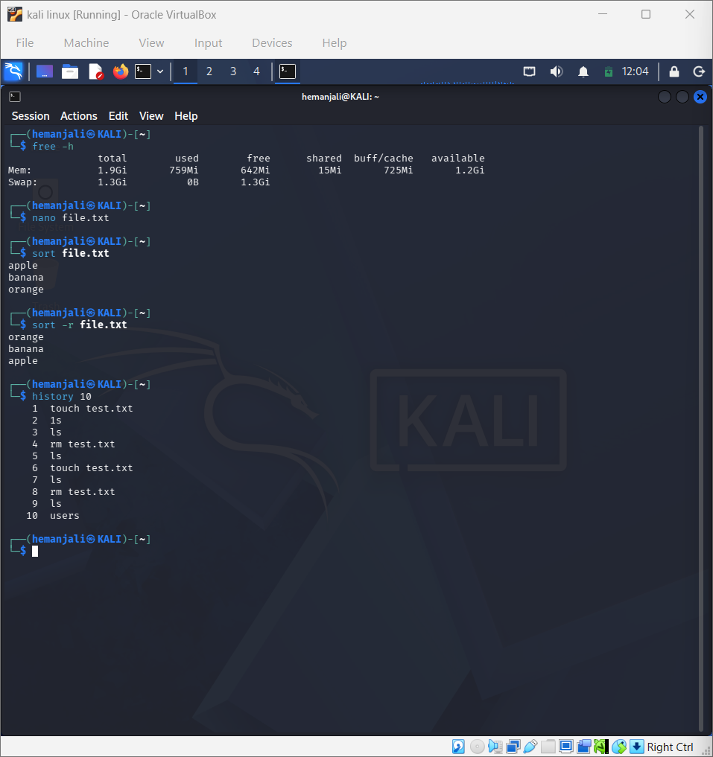
Result:
Successfully executed Free, Sort, and History commands in Kali Linux.

